

NATIONAL UNIVERSITY OF TECHNOLOGY
(Department of Computer Science)
CS161– Database Systems
Instructor: Miss Faiza khan
Name: Bisma Fatima
Roll no: f24605036

LAB TASK 11

In Lab Tasks
Database Structure Overview
∙ Books(BookID, Title, Author, ISBN, Price, StockQuantity)
∙ Customers(CustomerID, Name, Email, Address)
∙ Orders(OrderID, CustomerID, OrderDate, TotalAmount)
∙ OrderItems(OrderItemID, OrderID, BookID, Quantity, Price)
Task 1: Creating and Querying a Simple View
- Write a SQL CREATE VIEW statement to create a view named ActiveCustomers that shows CustomerID, CustomerName, and Country for all customers where IsActive = 1.
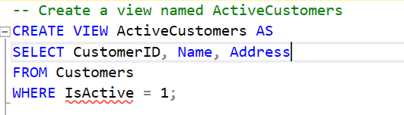

- Write a SQL SELECT query to retrieve all records from the ActiveCustomers view.
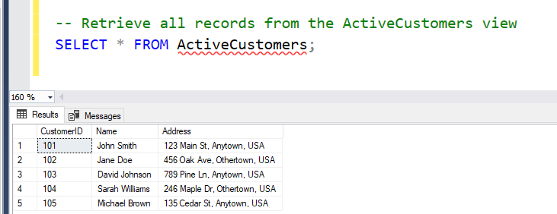
Task 2: Updating and Dropping Views
- Write a SQL CREATE OR ALTER VIEW statement to update the ActiveCustomers view to also include the Email column.
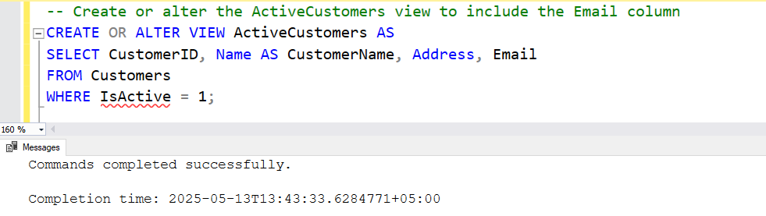

- Write a SQL statement to drop the ActiveCustomers view.
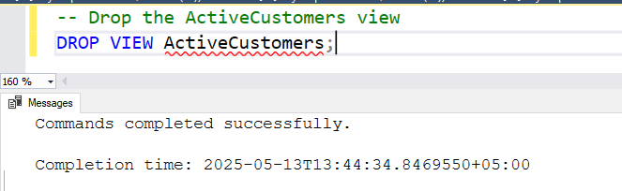
Task 3: Creating and Using Indexes

- Write a SQL CREATE INDEX statement to create a non-unique index named idx_Author on the Author column of the Books table.
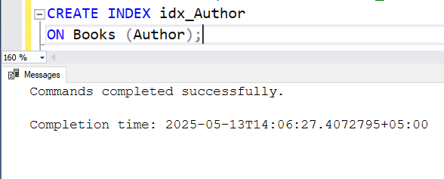
- Write a SQL CREATE UNIQUE INDEX statement named idx_ISBN on the ISBN column of the Books table.
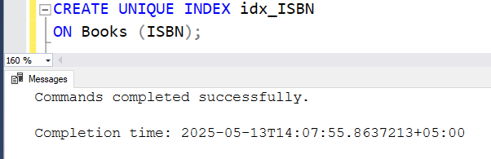
- Write a SQL DROP INDEX statement to remove the idx_Author index from the Books table.
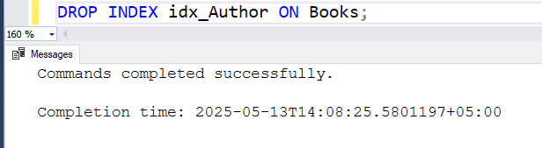
Task 4: Querying with Indexes
- Write a SQL SELECT query to find all books written by the author 'John Doe' from the Books table.
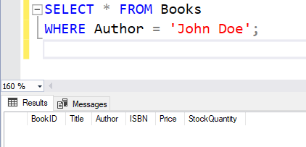
- Explain briefly how the index on Author helps speed up this query.
ANS:
Task 5: Understanding Functional Dependencies

- Using the Books table, write a SQL SELECT query to get all details for a book with BookID = 1.
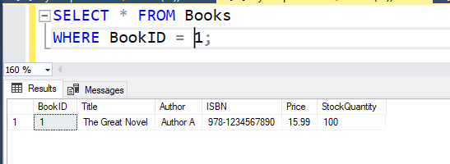

Post Lab Tasks
Task 1
Report Generation:
Write a report that includes:
- The SQL queries written for the In-Lab tasks.
- The output of each query (screenshots from your SQL database management system).
- A brief explanation of each query and its purpose.

